Resident Name:
Delamere Park Management Limited

 |  |  |  |  | Delamere Park Residents’ Club
 |  |  |  |  | 59 Delamere Parkway West
 | 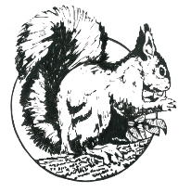 |  |  |  | Cuddington, Northwich
 |  |  |  |  | Cheshire CW8 2UJ
 |  |  |  |  | Telephone 01606 889263
 |  |  |  |  | Registered in England No. 1013623
Property Change Request Form 4
Work to Trees with TPO's or Protected Hedgerows
 | Property Address:
 | Location of tree/s:
 | Description of work proposed:
Required documentation:
Site plan showing tree location/s,
CW&C Application to carry out work,
tree reference number if known
 | …........................................For Office Use Only….............................................
 | Received date: |  |  |  | Resident consultation deadline:
 | Emailed to residents : |  |  |  | Posted on council notice board:
 | CW&C decision: |  |  |  | DPML decision:
 | This form will be displayed on the club house notice board for a period of 14 days.
 | To check if your tree or hedgerow is protected please visit the Cheshire West and Chester planning and building website for more information.
 | Removal of trees or hedges that are protected without CW&C permission can incur a £5,000.00 fine.

