Resident Name:
Delamere Park Management Limited

 | 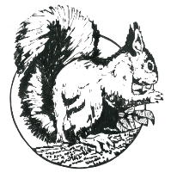 |  |  |  | Delamere Park Residents’ Club
 |  |  |  |  | 59 Delamere Parkway West
 |  |  |  |  | Cuddington, Northwich
 |  |  |  |  | Cheshire CW8 2UJ
 |  |  |  |  | Telephone 01606 889263
 |  |  |  |  | Registered in England No. 1013623
Property Change Request Form 3
Works requiring Building Regulations or Planning Approval
 | Property Address:
 | Detailed description of changes proposed:
Required documentation:

Site plans/sketches, Elevations, Material information, Exact dimensions
 | …........................................For Office Use Only…...........................................
 | Received date: |  |  |  | Resident consultation deadline:
 | Emailed to residents : |  |  |  | Posted on council notice board :
 | Resident informed date: |  |  |  | Decision given:
 | This form will be displayed on the club house notice board for a period of 14 days
 | Please Note: that any work undertaken to change a property or boundary without first obtaining trustee approval and that is subsequently rejected by the Trustees, will need to be returned to its original appearance at the plot holders’ own expense.
 | Delamere Park does not have Permitted Development Rights. Therefore, you will need to contact CW&C Planning Department to obtain either: full planning permission, or a document stating that planning permission is not required. The Trustees will not give any decision on an application until one of these documents has been provided.

