 |  |  |  | Resident Name
 | Delamere Park Management Limited
 |  |  |  |  |  |  | Delamere Park Residents’ Club
 | 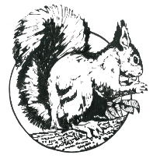 |  |  |  |  |  | 59 Delamere Parkway West
 |  |  |  |  |  |  | Cuddington, Northwich
 |  |  |  |  |  |  | Cheshire CW8 2UJ
 |  |  |  |  |  |  | Telephone 01606 889263
 |  |  |  |  |  |  | Registered in England No. 1013623
Property Change Request Form 1
Minor alterations and general maintenance
 | Property Address:
 | Description of changes proposed:
 | Supporting information e.g. product specifications, colour samples, plans, drawings
 | …........................................For Office Use Only…...........................................
 | Received date: |  |  |  |  | Resident consultation deadline:
 | Emailed to residents : |  |  |  |  | Posted on council notice board :
 | Resident informed date: |  |  |  |  | Decision given:
 | This form will be displayed on the club house notice board for a period of 14 days.
Please Note: that any work undertaken to change a property or boundary without first obtaining trustee approval and that is
subsequently rejected by the Trustees, will need to be returned to its original appearance at the plot holders’ own expense.

